**ATOMIC ENERGY CENTRAL SCHOOL – 3,ANUSHAKTINAGAR, MUMBAI**

**PERIODIC TEST - 1, EXAMINATION, 2024-2025**

**CLASS- VIII TIME- 90 Minutes**

**SUBJECT- SCIENCE Max Marks - 40**

**----------------------------------------------------------------------------------------------------------------**

**SECTION -A (1x9=9)**

**I. Choose and write the correct answer from the questions given below:**

1.The disease caused by a protozoan and spread by an insect is

a) Dengue b) Malaria c)Polio d) Measles

2.The gas released during the preparation of bread is

a) Oxygen b) Carbon di oxide c) Nitrogen d) Sulphur di oxide

3.The system of irrigation where water is supplied drop by drop near the roots of plants is called

a) Pulley system b) drip system c) sprinkler system d) lever system

4.The monsoon season in our country is during the months of

a) April- December b) June – September c)November – March d) January- May

5.Which substance is formed by the carbonisation of dead vegetation?

a) coal b) Coke c) coal gas d) coal tar

6. Which of the following is not a constituent of petroleum?

a) Paraffin wax b) lubricating oil c) Petrol d) Coke

7.The process of turning and loosening of soil is called

a) irrigation and manuring b) Digging and winnowing

c)Tilling and ploughing d) Harvesting and storage

8.Which of the following reproduces inside a host cell?

a) Bacteria b) Virus c) Amoeba d) Fugus

9. For this question two statements are given—one labelled **Assertion (A)** and the other labelled **Reason (R).** Select the correct answer to these questions from the **codes (a), (b), (c) and (d)** as given below. **(a) Both A and R are true, and R is the correct explanation of the assertion ( b) Both A and R are true, but R is not the correct explanation of the assertion**.

**(c) A is true, but R is false. (d) A is false, but R is true**.

Assertion – Pathogens are harmful to mankind.  
Reason – They either kill or prevent the growth of microorganisms.

**SECTION- B (5x2=10)**

II. Answer the following questions in one or two sentences:

10.Why is CNG considered a better fuel than petrol?

11.Name two devices used to store grains on a large scale.

12.What are weeds? Why is it necessary to remove weeds from fields?

13.What are antibiotics? Who discovered penicillin?

14.What is coke? What are its uses?

**SECTION – C (4x3=12)**

III. Answer the following questions in three to four two sentences:

15.Write the steps you would suggest for the judicious use of fuel.

16.While returning from school, Neha ate pani puris from street side. When she came home she complained of stomach pain and fell sick. What could be the reason?

17. What is the traditional tool for sowing of seeds ?What are the precautions to be taken while sowing seeds?

18.Observe the figure and answer the following questions.

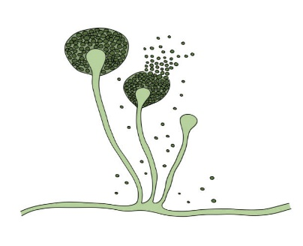

1. Name the microorganism and the group to which it belongs.
2. Name the food item on which this organism grows.
3. Does it grow well in dry or moist conditions?

**SECTION -D (1x4=4)**

 19. Microorganisms are used for various purposes. They are used in the preparation of curd, bread and cake. Microorganisms have been used for the production of alcohol since ages. They are also used in cleaning up of the environment.

i) In the process of fermentation the sugar is converted into...

(a) Vinegar (b) Curd (c) Salt (d) Alcohol

ii) What is fermentation?

iii) Name some of the common uses of microorganisms.

iv)Name the bacteria that helps in curd formation.

**SECTION -E (1X5= 5)**

20.Draw and explain the Nitrogen cycle

----------------------------------------------------------------------------------------------------------------